CECS447 Project 3 Bluetooth module

Introduction: In this project I will use the HC05 bluetooth module to make a bluetooth communication system between the TM4C123 MCU and PC.

Circuit diagram：

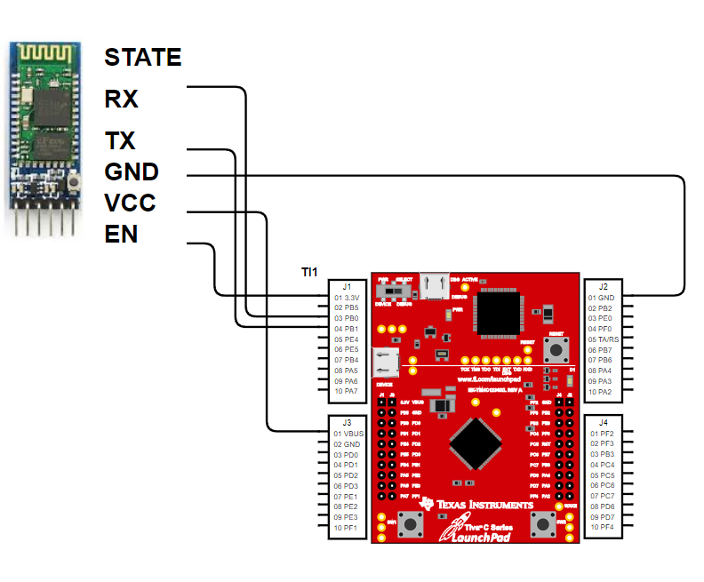

I used three GPIO Port in this project:

Port A: UART0, the communication between the PC and MCU.

Port B: UART1, the communication between the Bluetooth and MCU.

Port F: on board LED.

Instructions：

1.download the Bluetooth initializer with the EN pin connect with the MCU and Bluetooth module

2.run the program and then turn off the MCU and disconnect the EN pin of the HC05 Bluetooth module.

3.turn the MCU back on, use the PC to search the HC05 Bluetooth

4.after PC connected to the HC05, down the control program to the MCU

5.use the Bluetooth serial terminal to send the instructions to the Bluetooth module.

Code:

setupBLT.c

#include "tm4c123gh6pm.h"

#include "UART.h"

#include "string.h"

void Delay(void);

// main function for programming BT device with no UI

int main(void) {

char String[30];

UART_Init();

// setup the HC-05 bluetooth module

UART0_OutString("AT+NAME=KaiwenLiu\r\n"); // Name = Kaiwen Liu

UART1_OutString("AT+NAME=KaiwenLiu\r\n"); // Name = Kaiwen Liu

while ((UART1_FR_R&UART_FR_BUSY) != 0){};

BLT_InString(String);

UART0_OutString(String);

UART0_OutString("AT+UART=57600,0,1\r\n"); // baud rate = 57600, 1 stop bit, odd parity

UART1_OutString("AT+UART=57600,0,1\r\n"); // baud rate = 57600, 1 stop bit, odd parity

while ((UART1_FR_R&UART_FR_BUSY) != 0){};

BLT_InString(String);

UART0_OutString(String);

UART0_OutString("AT+PSWD=0825\r\n"); // Pass = 0825

UART1_OutString("AT+PSWD=0825\r\n"); // Pass = 0825

while ((UART1_FR_R&UART_FR_BUSY) != 0){};

BLT_InString(String);

UART0_OutString(String);

UART0_OutString("AT+ROLE=0\r\n"); // Mode = Slave

UART1_OutString("AT+ROLE=0\r\n"); // Mode = Slave

while ((UART1_FR_R&UART_FR_BUSY) != 0){};

BLT_InString(String);

UART0_OutString(String);

// query the HC-05 bluetooth module

UART0_OutString("AT+UART?\r\n"); // baud rate = 57600, 1 stop bit, odd parity

UART1_OutString("AT+UART?\r\n"); // baud rate = 57600, 1 stop bit, odd parity

while ((UART1_FR_R&UART_FR_BUSY) != 0){};

BLT_InString(String);

UART0_OutString(String);

UART0_OutString("AT+PSWD?\r\n"); // Pass = 0825

UART1_OutString("AT+PSWD?\r\n"); // Pass = 0825

while ((UART1_FR_R&UART_FR_BUSY) != 0){};

BLT_InString(String);

UART0_OutString(String);

UART0_OutString("AT+ROLE?\r\n"); // Mode = Slave

UART1_OutString("AT+ROLE?\r\n"); // Mode = Slave

while ((UART1_FR_R&UART_FR_BUSY) != 0){};

BLT_InString(String);

UART0_OutString(String);

UART0_OutString("AT+NAME?\r\n"); // Name = Kaiwen Liu

UART1_OutString("AT+NAME?\r\n"); // Name = Kaiwen Liu

while ((UART1_FR_R&UART_FR_BUSY) != 0){};

BLT_InString(String);

UART0_OutString(String);

while (1) {}

}

#include "PLL.h"

#include "UART.h"

#include "tm4c123gh6pm.h"

#define GPIO_PORTF_DATA_R (*((volatile unsigned long *)0x400253FC))

#define GPIO_PORTF_DIR_R (*((volatile unsigned long *)0x40025400))

#define GPIO_PORTF_AFSEL_R (*((volatile unsigned long *)0x40025420))

#define GPIO_PORTF_PUR_R (*((volatile unsigned long *)0x40025510))

#define GPIO_PORTF_DEN_R (*((volatile unsigned long *)0x4002551C))

#define GPIO_PORTF_LOCK_R (*((volatile unsigned long *)0x40025520))

#define GPIO_PORTF_CR_R (*((volatile unsigned long *)0x40025524))

#define GPIO_PORTF_AMSEL_R (*((volatile unsigned long *)0x40025528))

#define GPIO_PORTF_PCTL_R (*((volatile unsigned long *)0x4002552C))

#define SYSCTL_RCGC2_R (*((volatile unsigned long *)0x400FE108))

char lettersend;

//---------------------OutCRLF---------------------

// Output a CR,LF to UART to go to a new line

// Input: none

// Output: none

void OutCRLF(void){

UART_OutChar(CR);

UART_OutChar(LF);

}

//debug code

void UART1_Init(void){

SYSCTL_RCGCUART_R |= 0x0002;//activate UART1

SYSCTL_RCGCGPIO_R |= 0x0002;//activate port B

UART1_CTL_R &= ~0x0001; //disable UART

UART1_IBRD_R = 17; // IBRD = int(16,000,000 / (16 * 57600)) = int(17.3611111)

UART1_FBRD_R = 23; // FBRD = round(3611111 * 64) = 27

UART1_LCRH_R = 0x0070;//8bit length,enable FIFO;

UART1_CTL_R = 0x0301;//enable RXE,TXE and UART

GPIO_PORTB_AFSEL_R |= 0x03; // alt function on PB1-0

GPIO_PORTB_DEN_R |= 0x03;

GPIO_PORTB_PCTL_R = (GPIO_PORTB_PCTL_R&0xFFFFFF00)+0x00000011;

//UART1: PB0 -> U1Rx,PB1 -> U1tx

GPIO_PORTB_AMSEL_R &= ~0x03; // disable analog functionality on PB 0-1

}

void PortF_Init(void){ volatile unsigned long delay;

SYSCTL_RCGC2_R |= 0x00000020; // 1) activate clock for Port F

delay = SYSCTL_RCGC2_R; // allow time for clock to start

GPIO_PORTF_LOCK_R = 0x4C4F434B; // 2) unlock GPIO Port F

GPIO_PORTF_CR_R = 0x1F; // allow changes to PF4-0

// only PF0 needs to be unlocked, other bits can't be locked

GPIO_PORTF_AMSEL_R = 0x00; // 3) disable analog on PF

GPIO_PORTF_PCTL_R = 0x00000000; // 4) PCTL GPIO on PF4-0

GPIO_PORTF_DIR_R = 0x0E; // 5) PF4,PF0 in, PF3-1 out

GPIO_PORTF_AFSEL_R = 0x00; // 6) disable alt funct on PF7-0

GPIO_PORTF_PUR_R = 0x11; // enable pull-up on PF0 and PF4

GPIO_PORTF_DEN_R = 0x1F; // 7) enable digital I/O on PF4-0

GPIO_PORTF_IS_R &= ~0x11; // (d) PF4,PF0 is edge-sensitive

GPIO_PORTF_IBE_R &= ~0x11; // PF4,PF0 is not both edges

GPIO_PORTF_IEV_R &= ~0x11; // PF4,PF0 falling edge event

GPIO_PORTF_ICR_R = 0x11; // (e) clear flags 4,0

GPIO_PORTF_IM_R |= 0x11; // (f) arm interrupt on PF4,PF0

NVIC_PRI7_R = (NVIC_PRI7_R&0xFF1FFFFF)|0x00400000; // (g) bits:23-21 for PORTF, set priority to 2

NVIC_EN0_R = 0x40000000; // (h) enable interrupt 30 in NVIC

}

void carcontrol(char instructions){

if(instructions == 'w'){

GPIO_PORTF_DATA_R = 0x08; //'w : forward,green LED on'

}

else if(instructions == 's'){

GPIO_PORTF_DATA_R = 0x04; //'s : reverse, blue LED on'

}

else if(instructions == 'a'){

GPIO_PORTF_DATA_R = 0x0A; //'a : left turn, yellow LED on'

}

else if(instructions == 'd'){

GPIO_PORTF_DATA_R = 0x06; //'d : left turn, purple LED on'

}

else if(instructions == 't'){

GPIO_PORTF_DATA_R = 0x00; //'t : stop, all LED off'

}

else if(instructions == 'u'){

GPIO_PORTF_DATA_R =GPIO_PORTF_DATA_R;//'u, keep the same LED on'

}

else if(instructions == 'l'){

GPIO_PORTF_DATA_R =GPIO_PORTF_DATA_R;//'l, keep the same LED on'

}

}

int main(void){

unsigned char letterget;

char string[20];

PortF_Init();

UART_Init(); // initialize UART

UART1_Init();

while(1){

letterget = UART1_InChar();

UART_OutChar(letterget);

carcontrol(letterget);

}

}